Wizard Wars User Manual

Upon Opening the game, a menu will be displayed. The arrow keys and enter are used to navigate.
Play Game takes the user to the play game screen, which also displays options.
Instuctions takes the user to in game instructions as well as detailed descriptions of the wizards.
Exit exits them program.

In the Play Game screen, the user can select from a number of options, using left and right or enter to change the settings.
Start Game begins the game after options have been customized.
Player Specialties determine which powers each player has. A description of the abilities is depilated at the bottom of the screen.
Player Power determines the strength of each wizard. Higher powered wizards have larger effects with their magical abilities.
Screen Size determines the in game resolution. Full screen goes to the current resolution settings, small is 1000x500, medium is 1000x700, large is 1000x900.
Win Condition determines how the players can win. Score means the first person to gather the specified amount is the winner, while time means the person with the most points after specified time limit expires wins.
Game Length/Score to Win specifies the how to win for the win condition.
Back returns the player to the previous screen.

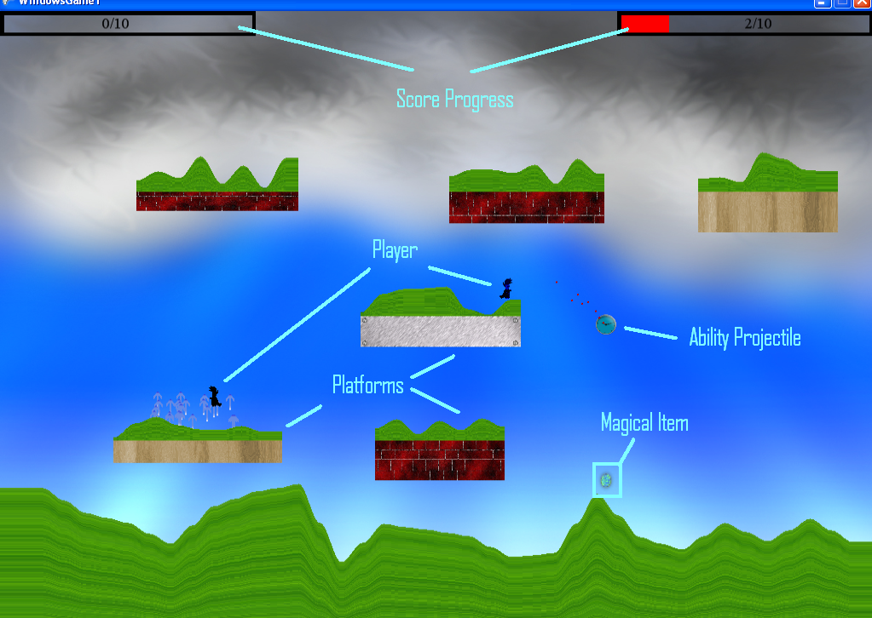

Player 1 uses the arrow keys to move and K and L to fire his projectiles. His score is displayed on the right
Player 2 uses WASD to move and F and G to fire his projectiles. His score is displayed on the Left.

They each try to get as many of the magical items as possible
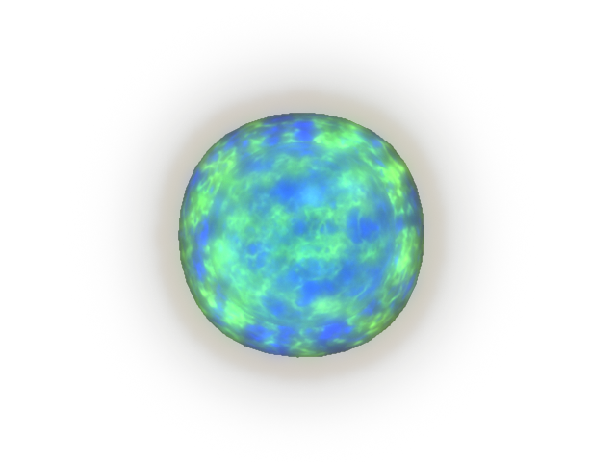
Tips and Hints:
Players can use aim their powers with the direction keys.
Many abilities can destroy terrain, use this to your advantage.
Be careful, other wizards can use the area effects you have created.
Projectiles are also affected by gravity, wind, and similar effects.
There may be some commands not noted here! Try and find them out.

Credits
Physics lead programming, debugging:
Paul Booth
Music, particle effects, class structuring, additional programming:
Ben Jann
Graphics Design and Artist:
Eric Kim
Sound Programming, Sound Effects, SVN manager and assistant programming:
Nick Maffei
Lead Programming:
Jon Paulson

Special Thanks to Alex Koren for the magical item graphics.
Thanks to all the beta testers.
